Supplementary Material: Use of the Zygoptera/Anisoptera ratio (Insecta: Odonata) for habitat alteration assessments in Cerrado streams
Authors: Wilmar Ferreira Da Silva Junior, Lenize Batista Calvão, Fernando Geraldo Carvalho, Emmy Fiorella Medina-Espinoza & Leandro Schlemmer Brasil

Anisoptera (Libellulidae) assemblage in the Cerrado biome in Mato Grosso (MT), Brazil. Data for the Nova Xavantina and Nova Nazaré streams of the state were adopted from Calvão et al. (2018) and Carvalho et al. (2013), respectively.

Source | Stream | Diastatops intensa | Diastatops obscura | Dythemis multipunctata | Elasmothemis cannacrioides | Erythemis credula | Erythrodiplax paraguayensis | Erythrodiplax amazonica | Erythrodiplax melanica
Carvalho et al. (2013) | Matrichan | 1 | 1 | 0 | 0 | 0 | 0 | 0 | 0
Carvalho et al. (2013) | Tritopá | 0 | 0 | 0 | 0 | 0 | 0 | 0 | 0
Carvalho et al. (2013) | Paca | 3 | 20 | 0 | 0 | 0 | 8 | 0 | 0
Carvalho et al. (2013) | Marayatobá | 0 | 3 | 0 | 0 | 0 | 0 | 0 | 0
Carvalho et al. (2013) | Areia Branca | 0 | 14 | 0 | 0 | 12 | 1 | 0 | 0
Carvalho et al. (2013) | ÁguaLimpa | 0 | 0 | 0 | 0 | 0 | 0 | 0 | 0
Carvalho et al. (2013) | Estrela | 0 | 0 | 0 | 0 | 0 | 0 | 0 | 0
Carvalho et al. (2013) | Cigano | 0 | 0 | 0 | 0 | 0 | 0 | 0 | 0
Carvalho et al. (2013) | Boa Esperança | 0 | 0 | 0 | 0 | 0 | 0 | 1 | 1
Carvalho et al. (2013) | Goiás | 0 | 0 | 0 | 0 | 0 | 0 | 0 | 0
Calvão et al. (2018) | Buriti | 0 | 1 | 0 | 0 | 0 | 0 | 2 | 0
Calvão et al. (2018) | Chupador | 0 | 0 | 2 | 0 | 0 | 0 | 0 | 0
Calvão et al. (2018) | Duilio | 0 | 0 | 0 | 0 | 0 | 0 | 0 | 0
Calvão et al. (2018) | Sucuri | 0 | 0 | 0 | 0 | 0 | 0 | 0 | 0
Calvão et al. (2018) | Buritizinho | 1 | 17 | 0 | 0 | 0 | 1 | 0 | 0
Calvão et al. (2018) | Caveira | 0 | 23 | 0 | 0 | 0 | 1 | 0 | 0
Calvão et al. (2018) | Esperança | 0 | 0 | 1 | 0 | 0 | 0 | 0 | 0
Calvão et al. (2018) | Murtinho | 0 | 7 | 0 | 5 | 0 | 0 | 0 | 0

 |  | Erythrodiplax
Source | Stream | Ery. basalis | Ery. avittata | Ery. fusca | Ery. juliana | Ery.latimaculata | Ery. maculosa | Ery. ochracea | Ery. umbrata
Carvalho et al. (2013) | Matrichan | 16 | 1 | 5 | 0 | 0 | 0 | 0 | 1
Carvalho et al. (2013) | Tritopá | 0 | 0 | 0 | 0 | 0 | 0 | 0 | 0
Carvalho et al. (2013) | Paca | 41 | 0 | 0 | 0 | 0 | 4 | 0 | 3
Carvalho et al. (2013) | Marayatobá | 64 | 0 | 2 | 1 | 0 | 0 | 0 | 0
Carvalho et al. (2013) | Areia Branca | 37 | 0 | 0 | 0 | 0 | 1 | 0 | 0
Carvalho et al. (2013) | ÁguaLimpa | 0 | 0 | 0 | 0 | 0 | 0 | 0 | 0
Carvalho et al. (2013) | Estrela | 0 | 0 | 0 | 0 | 0 | 0 | 0 | 0
Carvalho et al. (2013) | Cigano | 3 | 0 | 0 | 0 | 0 | 0 | 0 | 0
Carvalho et al. (2013) | Boa Esperança | 0 | 0 | 0 | 0 | 0 | 0 | 0 | 0
Carvalho et al. (2013) | Goiás | 0 | 0 | 0 | 0 | 0 | 0 | 0 | 0
Calvão et al. (2018) | Buriti | 0 | 0 | 0 | 6 | 0 | 0 | 0 | 0
Calvão et al. (2018) | Chupador | 0 | 0 | 0 | 10 | 0 | 0 | 0 | 0
Calvão et al. (2018) | Duilio | 0 | 0 | 0 | 1 | 0 | 0 | 0 | 0
Calvão et al. (2018) | Sucuri | 0 | 0 | 0 | 0 | 0 | 0 | 0 | 0
Calvão et al. (2018) | Buritizinho | 23 | 0 | 23 | 0 | 2 | 0 | 0 | 0
Calvão et al. (2018) | Caveira | 12 | 0 | 22 | 0 | 1 | 0 | 0 | 0
Calvão et al. (2018) | Esperança | 4 | 0 | 30 | 0 | 0 | 0 | 0 | 0
Calvão et al. (2018) | Murtinho | 39 | 0 | 4 | 2 | 0 | 0 | 1 | 0

Source | Stream | Fylgia amazonica | Gynothemis pumila | Gynothemi ssp. | Macrothemis hemichlora | Macrothemi ssp. | Miathyria marcella
Carvalho et al. (2013) | Matrichan | 0 | 0 | 2 | 0 | 1 | 0
Carvalho et al. (2013) | Tritopá | 0 | 0 | 1 | 0 | 0 | 0
Carvalho et al. (2013) | Paca | 0 | 0 | 0 | 0 | 0 | 0
Carvalho et al. (2013) | Marayatobá | 0 | 0 | 0 | 0 | 0 | 0
Carvalho et al. (2013) | Areia Branca | 0 | 0 | 0 | 0 | 0 | 6
Carvalho et al. (2013) | ÁguaLimpa | 0 | 0 | 0 | 0 | 0 | 0
Carvalho et al. (2013) | Estrela | 0 | 0 | 0 | 0 | 0 | 0
Carvalho et al. (2013) | Cigano | 11 | 0 | 0 | 0 | 0 | 0
Carvalho et al. (2013) | Boa Esperança | 7 | 0 | 0 | 0 | 0 | 0
Carvalho et al. (2013) | Goiás | 0 | 0 | 0 | 0 | 0 | 0
Calvão et al. (2018) | Buriti | 0 | 0 | 0 | 0 | 0 | 0
Calvão et al. (2018) | Chupador | 0 | 0 | 0 | 0 | 0 | 0
Calvão et al. (2018) | Duilio | 0 | 1 | 0 | 0 | 0 | 0
Calvão et al. (2018) | Sucuri | 0 | 0 | 0 | 0 | 0 | 0
Calvão et al. (2018) | Buritizinho | 0 | 0 | 0 | 0 | 0 | 0
Calvão et al. (2018) | Caveira | 0 | 0 | 0 | 0 | 0 | 0
Calvão et al. (2018) | Esperança | 0 | 0 | 0 | 1 | 0 | 0
Calvão et al. (2018) | Murtinho | 0 | 0 | 0 | 0 | 0 | 0

Source | Stream | Micrathyria atra | Micrathyria hesperis | Micrathyria pirassunungae | Micrathyria spuria | Micrathyriastawiarskii | Nephepeltia phryne
Carvalho et al. (2013) | Matrichan | 0 | 0 | 0 | 0 | 0 | 0
Carvalho et al. (2013) | Tritopá | 0 | 0 | 0 | 0 | 0 | 0
Carvalho et al. (2013) | Paca | 0 | 0 | 0 | 1 | 0 | 1
Carvalho et al. (2013) | Marayatobá | 0 | 0 | 0 | 0 | 0 | 0
Carvalho et al. (2013) | Areia Branca | 0 | 0 | 0 | 0 | 0 | 0
Carvalho et al. (2013) | ÁguaLimpa | 0 | 0 | 0 | 0 | 0 | 0
Carvalho et al. (2013) | Estrela | 0 | 0 | 0 | 0 | 0 | 0
Carvalho et al. (2013) | Cigano | 0 | 0 | 0 | 0 | 0 | 0
Carvalho et al. (2013) | Boa Esperança | 0 | 0 | 0 | 0 | 0 | 0
Carvalho et al. (2013) | Goiás | 0 | 0 | 0 | 0 | 1 | 0
Calvão et al. (2018) | Buriti | 0 | 0 | 1 | 0 | 0 | 0
Calvão et al. (2018) | Chupador | 0 | 0 | 0 | 0 | 0 | 0
Calvão et al. (2018) | Duilio | 1 | 0 | 0 | 0 | 0 | 0
Calvão et al. (2018) | Sucuri | 1 | 0 | 0 | 0 | 0 | 0
Calvão et al. (2018) | Buritizinho | 0 | 1 | 0 | 5 | 0 | 0
Calvão et al. (2018) | Caveira | 0 | 0 | 0 | 3 | 0 | 0
Calvão et al. (2018) | Esperança | 1 | 0 | 0 | 0 | 0 | 0
Calvão et al. (2018) | Murtinho | 0 | 0 | 0 | 0 | 0 | 0

Source | Stream | Oligoclada abbreviata | Oligocladapachystigma | Oligoclada raineyi | Oligoclada walkeri | Oligoclada xanthopleura | Orthemis ambirufa | Orthemis discolor | Orthemi ssp.
Carvalho et al. (2013) | Matrichan | 1 | 0 | 0 | 0 | 0 | 1 | 0 | 0
Carvalho et al. (2013) | Tritopá | 0 | 0 | 0 | 0 | 0 | 0 | 0 | 0
Carvalho et al. (2013) | Paca | 2 | 0 | 0 | 0 | 2 | 0 | 1 | 0
Carvalho et al. (2013) | Marayatobá | 0 | 0 | 0 | 0 | 0 | 0 | 1 | 0
Carvalho et al. (2013) | Areia Branca | 0 | 0 | 0 | 0 | 1 | 0 | 4 | 1
Carvalho et al. (2013) | ÁguaLimpa | 0 | 0 | 0 | 0 | 0 | 0 | 0 | 0
Carvalho et al. (2013) | Estrela | 0 | 1 | 0 | 1 | 0 | 0 | 0 | 0
Carvalho et al. (2013) | Cigano | 0 | 0 | 0 | 0 | 0 | 0 | 0 | 0
Carvalho et al. (2013) | Boa Esperança | 0 | 0 | 0 | 0 | 0 | 0 | 0 | 0
Carvalho et al. (2013) | Goiás | 0 | 0 | 0 | 0 | 0 | 0 | 1 | 0
Calvão et al. (2018) | Buriti | 0 | 0 | 0 | 0 | 0 | 0 | 0 | 0
Calvão et al. (2018) | Chupador | 0 | 0 | 0 | 0 | 0 | 0 | 0 | 0
Calvão et al. (2018) | Duilio | 0 | 0 | 0 | 0 | 0 | 0 | 0 | 0
Calvão et al. (2018) | Sucuri | 0 | 0 | 0 | 0 | 0 | 0 | 0 | 0
Calvão et al. (2018) | Buritizinho | 0 | 0 | 0 | 0 | 6 | 0 | 1 | 0
Calvão et al. (2018) | Caveira | 0 | 0 | 3 | 0 | 0 | 0 | 2 | 0
Calvão et al. (2018) | Esperança | 0 | 0 | 1 | 1 | 0 | 0 | 0 | 0
Calvão et al. (2018) | Murtinho | 0 | 0 | 0 | 0 | 2 | 0 | 0 | 0

Source | Stream | Perithemis electra | Perithemis lais | Perithemis tenera | Perithemis thais | Planiplax phoenicura | Planiplax sp. | Uracis reducta | Uracis siemensi | Zenithoptera viola
Carvalho et al. (2013) | Matrichan | 0 | 5 | 0 | 0 | 0 | 0 | 1 | 0 | 0
Carvalho et al. (2013) | Tritopá | 0 | 0 | 0 | 0 | 0 | 0 | 1 | 0 | 0
Carvalho et al. (2013) | Paca | 0 | 0 | 0 | 0 | 0 | 1 | 0 | 0 | 1
Carvalho et al. (2013) | Marayatobá | 0 | 0 | 0 | 0 | 0 | 0 | 0 | 0 | 0
Carvalho et al. (2013) | Areia Branca | 0 | 0 | 0 | 0 | 0 | 0 | 0 | 0 | 0
Carvalho et al. (2013) | ÁguaLimpa | 0 | 2 | 0 | 0 | 0 | 0 | 1 | 0 | 0
Carvalho et al. (2013) | Estrela | 0 | 5 | 0 | 0 | 0 | 0 | 0 | 0 | 0
Carvalho et al. (2013) | Cigano | 0 | 4 | 0 | 0 | 0 | 0 | 0 | 0 | 0
Carvalho et al. (2013) | Boa Esperança | 0 | 0 | 0 | 0 | 0 | 0 | 1 | 0 | 0
Carvalho et al. (2013) | Goiás | 0 | 0 | 0 | 0 | 0 | 0 | 0 | 0 | 0
Calvão et al. (2018) | Buriti | 0 | 0 | 0 | 0 | 0 | 0 | 0 | 2 | 0
Calvão et al. (2018) | Chupador | 0 | 0 | 0 | 0 | 0 | 0 | 0 | 0 | 0
Calvão et al. (2018) | Duilio | 0 | 0 | 0 | 1 | 0 | 0 | 0 | 0 | 0
Calvão et al. (2018) | Sucuri | 0 | 0 | 0 | 0 | 0 | 0 | 0 | 0 | 0
Calvão et al. (2018) | Buritizinho | 0 | 28 | 3 | 0 | 2 | 0 | 0 | 0 | 0
Calvão et al. (2018) | Caveira | 0 | 7 | 2 | 0 | 0 | 0 | 0 | 0 | 0
Calvão et al. (2018) | Esperança | 1 | 4 | 0 | 3 | 0 | 0 | 0 | 0 | 0
Calvão et al. (2018) | Murtinho | 0 | 3 | 0 | 0 | 0 | 0 | 0 | 0 | 0

Zygoptera assemblage in the Cerrado biome in Mato Grosso (MT), Brazil. Data for the Nova Xavantina and Nova Nazaré streams of the State were adopted from Calvão et al. (2018) and Carvalho et al. (2013), respectively.

 |  | Calopterygidae
Source | Stream | Hetaerinaauripennis | Hetaerina curvicauda | Hetaerina laesa | Hetaerina rosea | Hetaerina westfalli | Mnesareteguttifera |  | Mnesarete lencioni | Mnesarete williamsoni
Carvalho et al. (2013) | Matrichan | 0 | 13 | 0 | 2 | 0 | 0 | 2 |  | 1
Carvalho et al. (2013) | Tritopá | 0 | 20 | 0 | 3 | 0 | 0 | 0 |  | 0
Carvalho et al. (2013) | Paca | 0 | 0 | 0 | 1 | 0 | 0 | 0 |  | 0
Carvalho et al. (2013) | Marayatobá | 0 | 0 | 0 | 0 | 0 | 0 | 0 |  | 0
Carvalho et al. (2013) | Areia Branca | 0 | 1 | 0 | 0 | 0 | 0 | 0 |  | 0
Carvalho et al. (2013) | ÁguaLimpa | 0 | 0 | 0 | 2 | 0 | 0 | 0 |  | 0
Carvalho et al. (2013) | Estrela | 5 | 0 | 0 | 12 | 0 | 0 | 0 |  | 0
Carvalho et al. (2013) | Cigano | 0 | 9 | 1 | 0 | 0 | 0 | 0 |  | 0
Carvalho et al. (2013) | Boa Esperança | 0 | 0 | 0 | 0 | 0 | 0 | 0 |  | 0
Carvalho et al. (2013) | Goiás | 0 | 0 | 0 | 0 | 0 | 0 | 0 |  | 0
Calvão et al. (2018) | Buriti | 0 | 0 | 0 | 1 | 11 | 4 | 0 |  | 0
Calvão et al. (2018) | Chupador | 0 | 0 | 0 | 3 | 3 | 8 | 0 |  | 0
Calvão et al. (2018) | Duilio | 0 | 0 | 2 | 1 | 0 | 17 | 0 |  | 0
Calvão et al. (2018) | Sucuri | 0 | 0 | 1 | 0 | 0 | 4 | 0 |  | 0
Calvão et al. (2018) | Buritizinho | 0 | 0 | 0 | 0 | 0 | 0 | 0 |  | 0
Calvão et al. (2018) | Caveira | 0 | 0 | 0 | 1 | 0 | 0 | 0 |  | 0
Calvão et al. (2018) | Esperança | 0 | 0 | 0 | 20 | 0 | 0 | 0 |  | 0
Calvão et al. (2018) | Murtinho | 0 | 2 | 0 | 6 | 0 | 0 | 0 |  | 0

 |  | Coenagrionidae (Acanthagrion)
Source | Stream | Aca. abunae | Aca. apicale | Aca. ascendens | Aca. chacoense | Aca. gracile | Aca .jessei | Aca. minutum | Aca. sp1 | Aca. temporale | Aca. truncatum
Carvalho et al. (2013) | Matrichan | 0 | 3 | 0 | 0 | 0 | 1 | 0 | 0 | 0 | 0
Carvalho et al. (2013) | Tritopá | 0 | 0 | 0 | 0 | 0 | 1 | 0 | 0 | 0 | 0
Carvalho et al. (2013) | Paca | 0 | 0 | 0 | 0 | 0 | 10 | 0 | 5 | 0 | 0
Carvalho et al. (2013) | Marayatobá | 0 | 0 | 0 | 0 | 0 | 1 | 0 | 0 | 0 | 0
Carvalho et al. (2013) | Areia Branca | 0 | 0 | 0 | 0 | 0 | 0 | 0 | 0 | 0 | 0
Carvalho et al. (2013) | ÁguaLimpa | 0 | 0 | 1 | 0 | 0 | 0 | 0 | 0 | 0 | 0
Carvalho et al. (2013) | Estrela | 0 | 0 | 8 | 0 | 0 | 0 | 0 | 0 | 0 | 0
Carvalho et al. (2013) | Cigano | 0 | 7 | 0 | 0 | 0 | 0 | 0 | 0 | 0 | 0
Carvalho et al. (2013) | Boa Esperança | 0 | 9 | 0 | 0 | 0 | 1 | 0 | 0 | 0 | 0
Carvalho et al. (2013) | Goiás | 0 | 2 | 1 | 0 | 0 | 0 | 0 | 0 | 0 | 0
Calvão et al. (2018) | Buriti | 1 | 2 | 0 | 0 | 0 | 0 | 0 | 0 | 0 | 0
Calvão et al. (2018) | Chupador | 0 | 0 | 0 | 0 | 0 | 0 | 0 | 0 | 0 | 0
Calvão et al. (2018) | Duilio | 0 | 0 | 0 | 0 | 0 | 0 | 0 | 0 | 0 | 1
Calvão et al. (2018) | Sucuri | 0 | 1 | 0 | 0 | 0 | 0 | 0 | 0 | 0 | 0
Calvão et al. (2018) | Buritizinho | 0 | 0 | 0 | 1 | 9 | 0 | 9 | 0 | 1 | 53
Calvão et al. (2018) | Caveira | 0 | 0 | 0 | 0 | 41 | 0 | 0 | 0 | 0 | 33
Calvão et al. (2018) | Esperança | 0 | 0 | 11 | 0 | 43 | 0 | 0 | 0 | 0 | 0
Calvão et al. (2018) | Murtinho | 0 | 0 | 0 | 0 | 14 | 0 | 0 | 0 | 0 | 22

 |  | Coenagrionidae
Source | Stream | Aeolagrion flammeum | Argia chapadae | Argia hasemani | Argia lilacina | Argia mollis | Argia reclusa | Argia smithiana | Argia subapicalis | Argiatinc tipennis
Carvalho et al. (2013) | Matrichan | 0 | 0 | 0 | 0 | 0 | 9 | 0 | 0 | 0
Carvalho et al. (2013) | Tritopá | 3 | 0 | 0 | 0 | 15 | 15 | 0 | 0 | 0
Carvalho et al. (2013) | Paca | 0 | 0 | 0 | 0 | 0 | 1 | 0 | 0 | 0
Carvalho et al. (2013) | Marayatobá | 0 | 0 | 0 | 0 | 0 | 0 | 0 | 0 | 0
Carvalho et al. (2013) | Areia Branca | 0 | 0 | 0 | 0 | 0 | 0 | 0 | 0 | 0
Carvalho et al. (2013) | ÁguaLimpa | 2 | 0 | 0 | 0 | 0 | 6 | 0 | 0 | 0
Carvalho et al. (2013) | Estrela | 0 | 0 | 0 | 0 | 0 | 6 | 0 | 0 | 0
Carvalho et al. (2013) | Cigano | 0 | 0 | 0 | 0 | 0 | 0 | 0 | 0 | 0
Carvalho et al. (2013) | Boa Esperança | 0 | 0 | 0 | 0 | 0 | 0 | 0 | 0 | 0
Carvalho et al. (2013) | Goiás | 0 | 0 | 0 | 0 | 0 | 0 | 0 | 0 | 0
Calvão et al. (2018) | Buriti | 0 | 0 | 0 | 6 | 5 | 12 | 2 | 1 | 19
Calvão et al. (2018) | Chupador | 0 | 0 | 1 | 0 | 5 | 6 | 23 | 0 | 47
Calvão et al. (2018) | Duilio | 0 | 0 | 0 | 1 | 25 | 2 | 1 | 3 | 15
Calvão et al. (2018) | Sucuri | 0 | 1 | 0 | 0 | 5 | 0 | 0 | 0 | 21
Calvão et al. (2018) | Buritizinho | 0 | 0 | 0 | 0 | 0 | 0 | 0 | 0 | 0
Calvão et al. (2018) | Caveira | 0 | 0 | 0 | 0 | 0 | 0 | 0 | 0 | 0
Calvão et al. (2018) | Esperança | 0 | 0 | 0 | 0 | 0 | 8 | 2 | 0 | 2
Calvão et al. (2018) | Murtinho | 0 | 0 | 0 | 23 | 0 | 5 | 0 | 0 | 0

 |  | Coenagrionidae
Source | Stream | Oxyagrionchapadense | Oxyagrionfernandoi | Oxyagrion sulmatogrossense | Peristictaaenoviridis | Protoneura tenuis | Telebasiscoccinea | Telebasis gigantea
Carvalho et al. (2013) | Matrichan | 0 | 0 | 0 | 5 | 0 | 0 | 0
Carvalho et al. (2013) | Tritopá | 0 | 0 | 0 | 0 | 1 | 0 | 0
Carvalho et al. (2013) | Paca | 0 | 0 | 0 | 0 | 0 | 0 | 0
Carvalho et al. (2013) | Marayatobá | 0 | 0 | 0 | 0 | 0 | 0 | 0
Carvalho et al. (2013) | Areia Branca | 0 | 0 | 0 | 0 | 0 | 0 | 0
Carvalho et al. (2013) | ÁguaLimpa | 0 | 0 | 0 | 0 | 0 | 0 | 0
Carvalho et al. (2013) | Estrela | 0 | 0 | 0 | 0 | 0 | 0 | 0
Carvalho et al. (2013) | Cigano | 0 | 0 | 0 | 0 | 0 | 0 | 0
Carvalho et al. (2013) | Boa Esperança | 0 | 0 | 0 | 0 | 0 | 0 | 0
Carvalho et al. (2013) | Goiás | 0 | 0 | 0 | 0 | 0 | 0 | 0
Calvão et al. (2018) | Buriti | 2 | 0 | 1 | 0 | 1 | 0 | 3
Calvão et al. (2018) | Chupador | 1 | 0 | 0 | 0 | 2 | 0 | 0
Calvão et al. (2018) | Duilio | 0 | 0 | 0 | 0 | 0 | 0 | 0
Calvão et al. (2018) | Sucuri | 3 | 0 | 0 | 0 | 0 | 0 | 0
Calvão et al. (2018) | Buritizinho | 0 | 8 | 0 | 0 | 0 | 0 | 0
Calvão et al. (2018) | Caveira | 0 | 0 | 0 | 0 | 0 | 0 | 0
Calvão et al. (2018) | Esperança | 6 | 0 | 0 | 0 | 0 | 0 | 0
Calvão et al. (2018) | Murtinho | 0 | 0 | 0 | 0 | 0 | 1 | 0

 |  | Coenagrionidae |  | Dicteriaridae | Perilestidae | Polythoridae
Source | Stream | Tigriagrion aurantinigrum | Tuberculobasis inversa | Heliocharis amazona | Perilestes solutus | Chalcopteryx rutilans
Carvalho et al. (2013) | Matrichan | 9 | 0 | 0 | 0 | 0
Carvalho et al. (2013) | Tritopá | 0 | 0 | 0 | 0 | 0
Carvalho et al. (2013) | Paca | 6 | 0 | 0 | 0 | 0
Carvalho et al. (2013) | Marayatobá | 0 | 0 | 0 | 0 | 0
Carvalho et al. (2013) | Areia Branca | 0 | 0 | 0 | 0 | 0
Carvalho et al. (2013) | ÁguaLimpa | 0 | 0 | 0 | 0 | 0
Carvalho et al. (2013) | Estrela | 0 | 0 | 0 | 0 | 0
Carvalho et al. (2013) | Cigano | 2 | 0 | 0 | 0 | 0
Carvalho et al. (2013) | Boa Esperança | 0 | 0 | 0 | 0 | 0
Carvalho et al. (2013) | Goiás | 0 | 0 | 0 | 0 | 0
Calvão et al. (2018) | Buriti | 1 | 0 | 0 | 0 | 0
Calvão et al. (2018) | Chupador | 1 | 0 | 0 | 0 | 0
Calvão et al. (2018) | Duilio | 0 | 0 | 0 | 0 | 2
Calvão et al. (2018) | Sucuri | 0 | 0 | 0 | 0 | 0
Calvão et al. (2018) | Buritizinho | 8 | 0 | 0 | 0 | 0
Calvão et al. (2018) | Caveira | 16 | 0 | 0 | 0 | 0
Calvão et al. (2018) | Esperança | 7 | 0 | 0 | 3 | 0
Calvão et al. (2018) | Murtinho | 12 | 1 | 1 | 0 | 0

 |  | Coenagrionidae
Source | Stream | Cyanallagma ferenigrum | Epipleoneura machadoi | Epipleoneura metallica | Helveciagrion obsoletum | Homeoura nepos | Ischnuracapreolus | Ischnura fluviatilis | Neoneura sylvatica
Carvalho et al. (2013) | Matrichan | 0 | 9 | 0 | 0 | 0 | 0 | 0 | 3
Carvalho et al. (2013) | Tritopá | 0 | 3 | 0 | 0 | 0 | 0 | 0 | 2
Carvalho et al. (2013) | Paca | 0 | 1 | 0 | 0 | 0 | 1 | 0 | 0
Carvalho et al. (2013) | Marayatobá | 0 | 0 | 0 | 0 | 0 | 0 | 0 | 0
Carvalho et al. (2013) | Areia Branca | 0 | 0 | 0 | 0 | 0 | 0 | 0 | 0
Carvalho et al. (2013) | ÁguaLimpa | 0 | 0 | 1 | 0 | 0 | 0 | 0 | 0
Carvalho et al. (2013) | Estrela | 0 | 0 | 10 | 0 | 0 | 0 | 0 | 3
Carvalho et al. (2013) | Cigano | 0 | 0 | 0 | 1 | 0 | 0 | 0 | 0
Carvalho et al. (2013) | Boa Esperança | 0 | 0 | 0 | 0 | 0 | 0 | 0 | 0
Carvalho et al. (2013) | Goiás | 0 | 1 | 0 | 0 | 0 | 0 | 0 | 0
Calvão et al. (2018) | Buriti | 0 | 0 | 0 | 0 | 0 | 0 | 0 | 0
Calvão et al. (2018) | Chupador | 0 | 0 | 0 | 0 | 0 | 0 | 0 | 3
Calvão et al. (2018) | Duilio | 0 | 0 | 0 | 0 | 0 | 0 | 0 | 0
Calvão et al. (2018) | Sucuri | 0 | 0 | 0 | 0 | 0 | 0 | 0 | 0
Calvão et al. (2018) | Buritizinho | 5 | 0 | 0 | 0 | 8 | 19 | 2 | 8
Calvão et al. (2018) | Caveira | 2 | 0 | 0 | 0 | 0 | 0 | 0 | 2
Calvão et al. (2018) | Esperança | 0 | 0 | 0 | 0 | 0 | 0 | 0 | 0
Calvão et al. (2018) | Murtinho | 5 | 0 | 3 | 0 | 0 | 0 | 0 | 13

Habitat Integrity Index of the streams sampled in the Cerrado biome in Mato Grosso (MT), Brazil. Data for the Nova Xavantina and Nova Nazaré streams of the state were adopted from Calvão et al. (2018) and Carvalho et al. (2013), respectively.

Source | Stream | Habitat Integrity Index
Carvalho et al. (2013) | Matrichan | 0.664
Carvalho et al. (2013) | Tritopá | 0.774
Carvalho et al. (2013) | Paca | 0.264
Carvalho et al. (2013) | Marayatobá | 0.293
Carvalho et al. (2013) | Areia Branca | 0.306
Carvalho et al. (2013) | ÁguaLimpa | 0.701
Carvalho et al. (2013) | Estrela | 0.685
Carvalho et al. (2013) | Cigano | 0.807
Carvalho et al. (2013) | Boa Esperança | 0.838
Carvalho et al. (2013) | Goiás | 0.596
Calvão et al. (2018) | Buriti | 0.963
Calvão et al. (2018) | Chupador | 0.963
Calvão et al. (2018) | Duilio | 0.963
Calvão et al. (2018) | Sucuri | 0.879
Calvão et al. (2018) | Buritizinho | 0.118
Calvão et al. (2018) | Caveira | 0.125
Calvão et al. (2018) | Esperança | 0.339
Calvão et al. (2018) | Murtinho | 0.360

- Beta regression models describing the influence of the habitat integrity (as habitat integrity index, HII) on the proportion of Anisoptera in the Cerrado biome, Brazil. SE: standard error; R²: Nagelkerke's R²; Statistically significant effects (p<0.05) in bold.
Ratio | Metric |  | Estimate | SE | z-value | p-value | R²
Anisoptera ratio |  | Richness | 2.348 | 0.574 | 4.091 | <0.001 | 0.488
 |  | Abundance | -3.175 | 0.902 | 3.519 | <0.001 | 0.407

Goodness of fit of the models that evaluate the influence of the state of habitat on the Zygoptera/Anisoptera ratio in the Cerrado biome in Mato Grosso (MT), Brazil.

Influence of habitat integrity on the proportion of Zygoptera richness
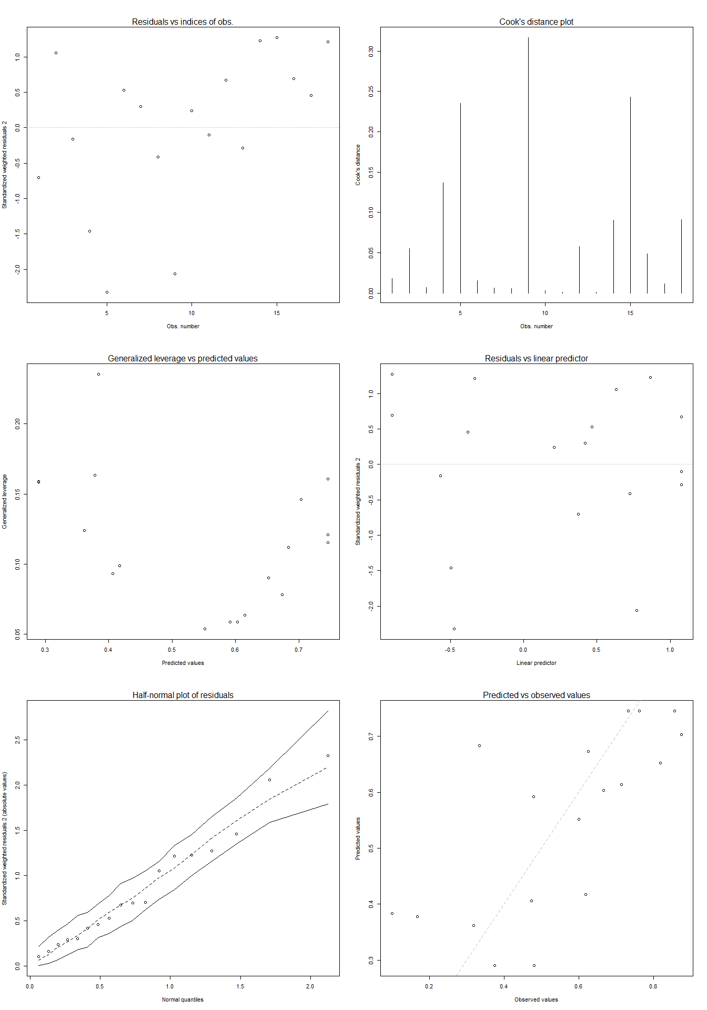

b) Influence of habitat integrity on the proportion of Anisoptera richness

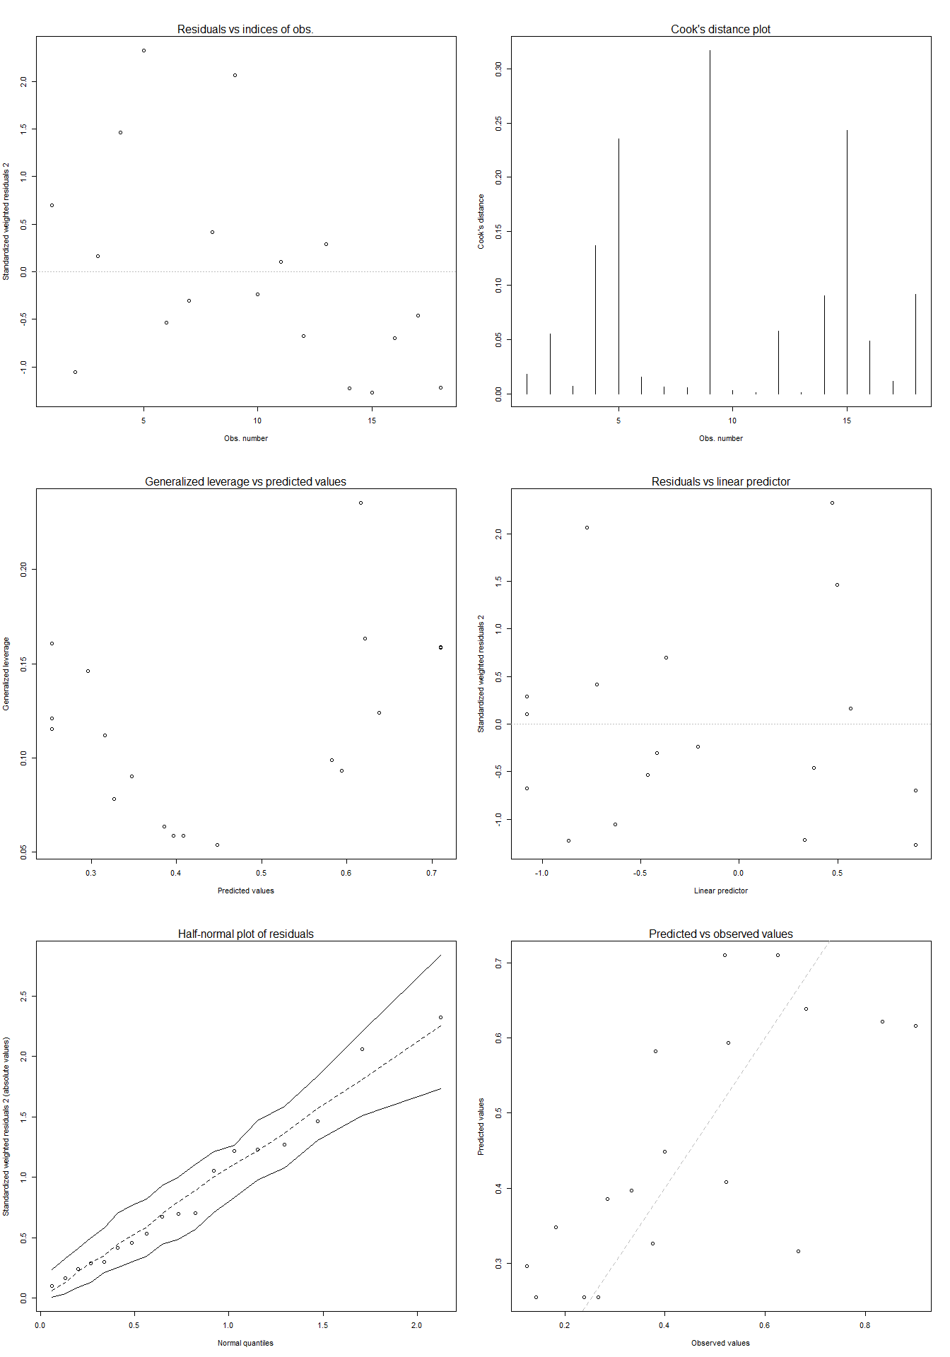

c) Influence of habitat integrity on the proportion of Zygoptera abundance
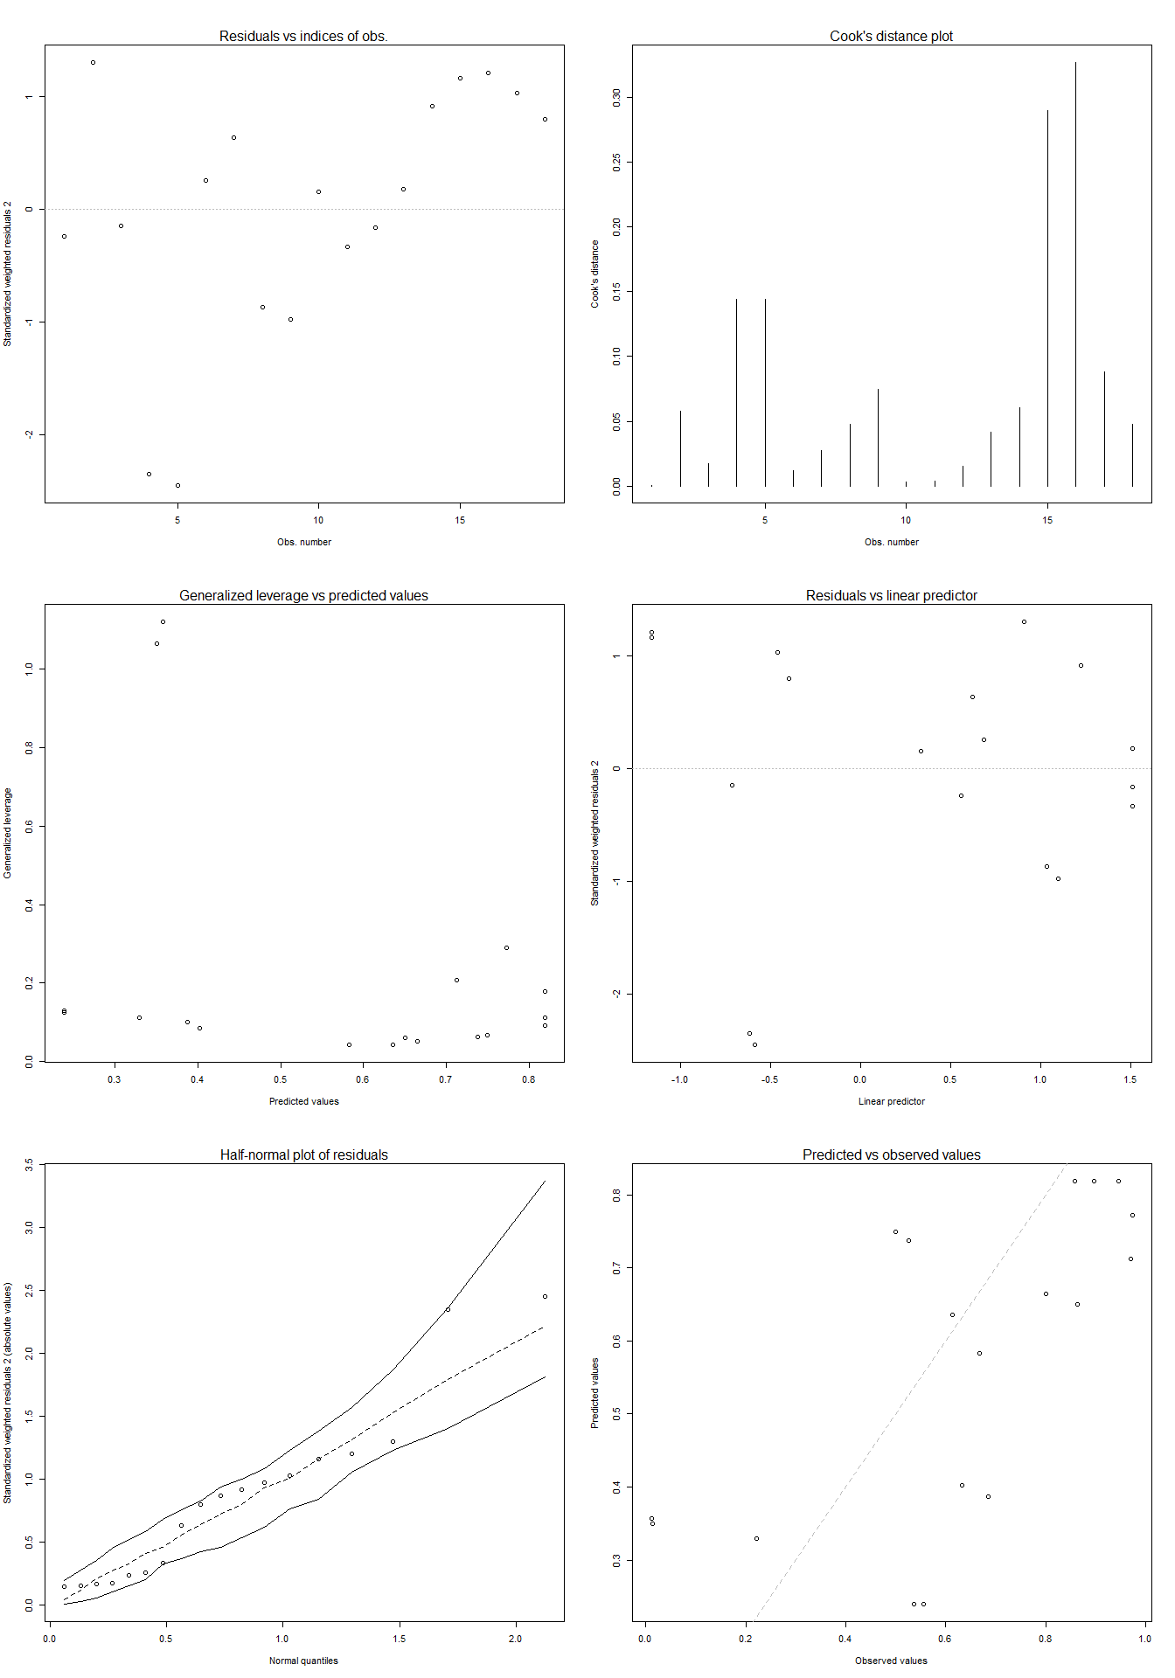

d) Influence of habitat integrity on the proportion of Anisoptera abundance.
